OpenTenure Android development setup

The following steps allow for setting up an environment for the development of the Android mobile application for OpenTenure.

Two development profiles will be considered:

1. Minimal: only dealing with building and deploying the application from the command line for release or testing purpose.
2. Full: dealing with development and maintenance using the IDE

Both will be created on a computer running Windows (7/8/8.1). The target audience is supposed to be familiar with:

* creating , deleting and modifying files and directories
* accessing the command prompt and executing commands
* extracting compressed files
* installing programs

on such platform.

Minimal profile:

1) Download and install Java Java SE 7uXX JDK (the latest available update in the series) from <http://www.oracle.com/technetwork/java/javase/downloads/index.html>. Check that the JAVA_HOME environment variable exists and points to the installation directory of the JDK. Check that %JAVA_HOME%\bin is included in the Path environment variable value.

2) Download and install the latest available Android SDK version from <http://developer.android.com/sdk/index.html>. Create the ANDROID_HOME environment variable pointing to the installation directory of the Android SDK and add %ANDROID_HOME%\tools and %ANDROID_HOME%\platform-tools to the Path environment variable.

3) Download version 4.4.2 (API 19) of the android platform as described in <http://developer.android.com/sdk/installing/adding-packages.html>.

4) Install maven 3.2.x (latest) from maven.apache.org according to <http://maven.apache.org/download.html#Installation> (define the MAVEN_HOME add %MAVEN_HOME%\bin to Path)

Create an android project to initialize maven using

On Linux :

mvn archetype:generate \

-DarchetypeArtifactId=android-quickstart \

-DarchetypeGroupId=de.akquinet.android.archetypes \

-DarchetypeVersion=1.0.11 \

-DgroupId=org.fao \

-DartifactId=maven-initialize \

-Dplatform=19 \

-Dversion=1.0.0

On Windows :

mvn archetype:generate ^

-DarchetypeArtifactId=android-quickstart ^

-DarchetypeGroupId=de.akquinet.android.archetypes ^

-DarchetypeVersion=1.0.11 ^

-DgroupId=org.fao ^

-DartifactId= maven-initialize ^

-Dplatform=19 ^

-Dversion=1.0.0

Install android artifacts to your local maven repository using the following commands

On Linux

mvn install:install-file \

-Dfile=”<android home>/extras/android/support/v4/android-support-v4.jar” \

-DgroupId=com.google.android \

-DartifactId=android-support-v4 \

-Dversion=<support platform> \

-Dpackaging=jar

mvn install:install-file \

-Dfile=”<android home>/platforms/android-<platform>/android.jar” \

-DgroupId=com.google.android \

-DartifactId=android \

-Dversion=<platform> \

-Dpackaging=jar

On Windows

mvn install:install-file ^

-Dfile=”<android home>/extras/android/support/v4/android-support-v4.jar” ^

-DgroupId=com.google.android ^

-DartifactId=android-support-v4 ^

-Dversion=<support platform> ^

-Dpackaging=jar

mvn install:install-file ^

-Dfile=”<android home>/platforms/android-<platform>/android.jar” ^

-DgroupId=com.google.android ^

-DartifactId=android ^

-Dversion=<platform> ^

-Dpackaging=jar

replacing <android home>, <support platform> and <platform> as appropriate (<platform>=19 and <support platform>=19.0.1 for OpenTenure development)

NOTE: If you are not interested in upgrading to the full profile later, you can replace steps 2 to 4 with cloning the ot-dependencies repository on GitHub by running

git clone <https://github.com/OpenTenure/ot-dependencies.git>

and running

mvn install:install-file \

-Dfile=android-support-v4.jar \

-DgroupId=com.google.android \

-DartifactId=android-support-v4 \

-Dversion=19.0.1 \

-Dpackaging=jar

mvn install:install-file \

-Dfile=android.jar \

-DgroupId=com.google.android \

-DartifactId=android \

-Dversion=19 \

-Dpackaging=jar

from the ot-dependencies directory to push dependencies to your private maven repository.

5) Download the aFileChooser project from <https://github.com/iPaulPro/aFileChooser/archive/master.zip> and extract the aFileChooser directory from it.

In the aFileChooser directory, create a pom.xml file containing

<?xml version="1.0" encoding="UTF-8"?>

<project xmlns="http://maven.apache.org/POM/4.0.0" xmlns:xsi="http://www.w3.org/2001/XMLSchema-instance"

xsi:schemaLocation="http://maven.apache.org/POM/4.0.0 http://maven.apache.org/maven-v4_0_0.xsd">

<modelVersion>4.0.0</modelVersion>

<groupId>com.ipaulpro</groupId>

<artifactId>afilechooser</artifactId>

<version>1.0.0</version>

<packaging>apklib</packaging>

<name>aFileChooser</name>

<dependencies>

<dependency>

<groupId>com.google.android</groupId>

<artifactId>android</artifactId>

<version>19</version>

<scope>provided</scope>

</dependency>

<dependency>

<groupId>com.google.android</groupId>

<artifactId>android-support-v4</artifactId>

<version>19.0.1</version>

</dependency>

</dependencies>

<build>

<sourceDirectory>src</sourceDirectory>

<finalName>${project.artifactId}</finalName>

<pluginManagement>

<plugins>

<plugin>

<groupId>com.jayway.maven.plugins.android.generation2</groupId>

<artifactId>android-maven-plugin</artifactId>

<version>3.9.0-rc.2</version>

<extensions>true</extensions>

</plugin>

</plugins>

</pluginManagement>

<plugins>

<plugin>

<groupId>com.jayway.maven.plugins.android.generation2</groupId>

<artifactId>android-maven-plugin</artifactId>

<configuration>

<sdk>

<platform>19</platform>

</sdk>

</configuration>

</plugin>

</plugins>

</build>

</project>

6) Move to aFileChooser project directory level and run the following command

mvn android:apklib

to create an android library from the project and push it to your local maven repository using

mvn install:install-file -Dfile=target\afilechooser.apklib -DgroupId=com.ipaulpro -DartifactId=afilechooser -Dversion=1.0.0 -Dpackaging=apklib

7)

From <https://github.com/OpenTenure/ot-android> use ‘’Download Zip’’ button to download the project.

Extract the OpenTenure directory from OpenTenure.zip. You can now manage the OpenTenure mobile application lifecycle by running the following maven commands

|  |  |
| --- | --- |
| **Maven target** | **Purpose** |
| mvn clean | Remove build result |
| mvn android:generate-sources | Generate classes from xml resources |
| mvn compile | Compile classes |
| mvn android:dex | Package compile classes |
| mvn android:apk | Create application package |
| mvn android:deploy | Push application package to a connected device |
| mvn android:run | Run the application on a connected device |

All of the above targets can be executed in one single command line:

mvn clean android:generate-sources compile android:dex android:apk android:deploy android:run

in the OpenTenure directory.

Follow <http://books.sonatype.com/mvnref-book/reference/android-dev.html> for additional information on android development using maven.

Full profile

In order to upgrade to the full development profile the following additional steps are required:

Install Eclipse Kepler 4.3.x from <http://www.eclipse.org/downloads/> (select the Java or Java EE Developer bundle).

Install Eclipse the ADT (Android Development Tools) plugin as described in <http://developer.android.com/sdk/installing/installing-adt.html>. Don’t forget to configure the location of the Android SDK as a final step.

As a reminder, notice that Open Tenure uses the following external projects as android library dependencies:

* aFileChooser (com.ipaulpro)
* google-play-services (com.google.android.gms)
* nineoldandroids (com.nineoldandroids)

These must be downloaded, compiled and added as android library dependencies to Open Tenure project.

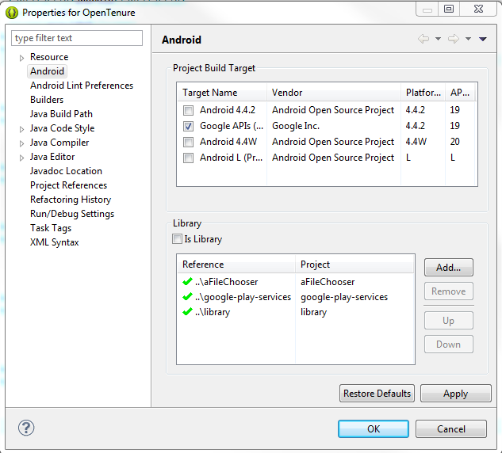

Be aware of the fact that when downloaded and compiled “nineoldandroids” is automatically named “library”.